

Foundations of Programming
Assignment No. : 12

PROBLEM STATEMENT:
Write a program in C to accept two numbers from the user and compute:
- The smallest common divisor of the two numbers (other than 1, if any)
- The Greatest Common Divisor (GCD) of the two numbers

OBJECTIVE:
• To understand the use of mathematical operations in C.
• To implement loops and conditional statements
. • To perform number-based computations.
• To enhance logical thinking using menu-driven programs.

THEORY:
Divisors and the Greatest Common Divisor (GCD) are fundamental concepts in number theory. The smallest common divisor of two numbers is the smallest positive integer greater than 1 that divides both numbers. The GCD of two numbers is the largest positive integer that divides both numbers without leaving a remainder. In C programming, these operations can be efficiently implemented using loops and the Euclidean algorithm, which repeatedly applies the modulo operation until the remainder becomes zero.

PLATFORM:
Linux

ALGORITHM:
Start.
Input: Read two integer numbers, say num1 and num2, from the user.
Smallest Common Divisor (SCD):
- Initialize a variable scd to 0.
- Find the minimum of the two numbers.
- Loop from $i = 2$ up to the minimum value.
- If both num1 % i == 0 and num2 % i == 0, set scd = i and break the loop (this ensures it is the smallest).
Greatest Common Divisor (GCD) using Euclidean Algorithm:
- Create temporary variables a = num1 and b = num2.
- While b is not equal to 0:
  - Calculate remainder = a % b.
  - Update a = b.
  - Update b = remainder.
- The final value of a is the GCD.
Output: Display the SCD and the GCD.
Stop.

FLOWCHART:

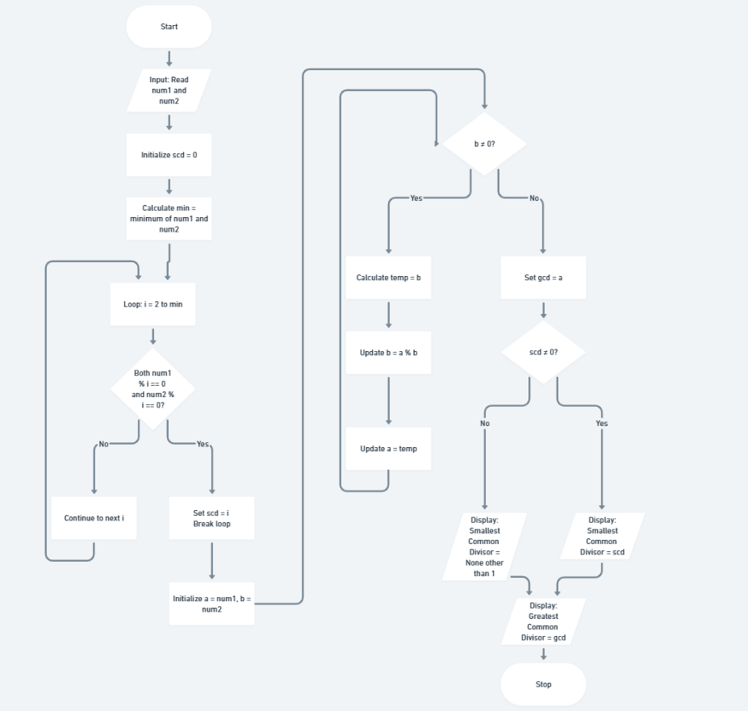

C PROGRAM:
#include <stdio.h>

int main() {
int num1, num2, i, min, scd = 0;
int a, b, temp, gcd;

// Input from user [cite: 4, 23]
printf("Enter first number: ");
scanf("%d", &num1);
printf("Enter second number: ");
scanf("%d", &num2);

// 1. Finding Smallest Common Divisor (Other than 1) [cite: 5, 14]
min = (num1 < num2) ? num1 : num2;
for (i = 2; i <= min; i++) {
if (num1 % i == 0 && num2 % i == 0) {
scd = i;
break; // Exit at the first common divisor found
}
}

// 2. Finding GCD using Euclidean Algorithm [cite: 6, 16]
a = num1;
b = num2;
while (b != 0) {
temp = b;
b = a % b;
a = temp;
}
gcd = a;

// Output results
printf("\n--- Results ---\n");
if (scd != 0) {
printf("Smallest Common Divisor: %d\n", scd);
} else {
printf("Smallest Common Divisor: None (other than 1)\n");
}
printf("Greatest Common Divisor (GCD): %d\n", gcd);

return 0;
}

INPUT/OUTPUT:

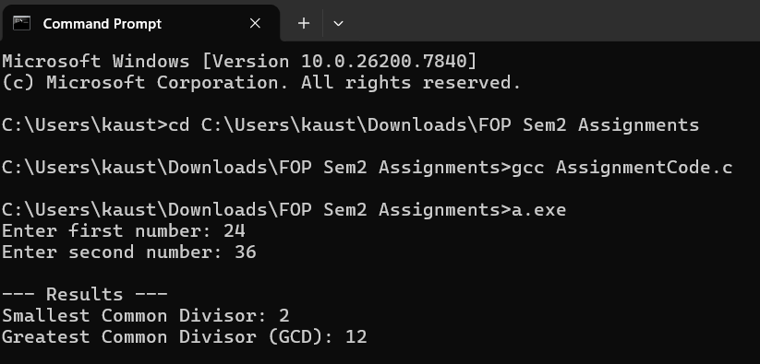CONCLUSION:
Thus, the program to find the smallest common divisor and the Greatest Common Divisor of two numbers was successfully implemented using C programming. This program demonstrates the use of loops, conditional statements, and the Euclidean algorithm.

FAQs:
- What is meant by the Greatest Common Divisor (GCD)?
- Why does the Euclidean algorithm efficiently compute the GCD?
- How can this program be modified to handle negative numbers?
- What changes are required to compute the Least Common Multiple (LCM) using the GCD?
- How can this program be extended to find the LCM of two numbers?

